Tree Flipping

**Summary:**

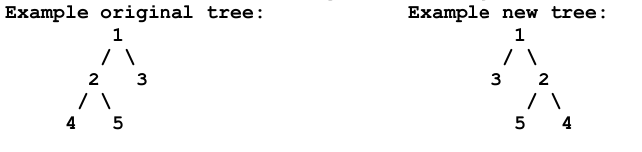Assume a binary tree. There’s a flip method that takes the node which the mirror image of the tree will start from, if no parameter send to the function the default value will be the root node.  
Prototype: **void** **flip(Node* node = root)**

The project is built using **C++, Visual Studio**.